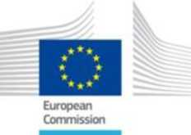

12th edition of the

Online Summer School on

Nuclear Decommissioning and Waste Management
European Commission, Joint Research Centre

6-10 September 2021, Online
If you are interested to attend the Summer School, please fill-in and sign this application form (2 pages), and mail it, with copy of your student card (or equivalent document proving your affiliation as student), to Daniela Santopolo:
daniela.santopolo@ec.europa.eu
Be informed that the application is at this stage only an expression of interest.
Your information will be reviewed and you will receive as a next step a confirmation and detailed logistic information.
The course is limited to 100 participants.
APPLICATION FORM
Name:
First name:
Address:
Country:
e-mail:
Age:
Nationality:

University or High School Studies:
Your highest obtained academic diploma (graduate, bachelor, Bac+3 or eq.) or expected to be obtained by July 2021 :
Name and location of the University or High School from which you obtained the diploma:
Your currently on-going academic studies (master, Bac+5 or eq.):
Name and location of the University or High School where you are currently studying:

I hereby certify that the above-mentioned information is correct, that I am student and do not have currently a remunerated professional activity.
Date:
Signature:
Comments (if any):
Please do not forget to attach also a copy of your student card (or an equivalent document proving your affiliation as student).

